**Using Foursquare API to Choose a Location Between Victoria Island and Ikeja for Your New Restaurant**

Victoria Island (VI) is an affluent area that encompasses a former [island](https://en.wikipedia.org/wiki/Island) of the same name neighbouring [Lagos Island](https://en.wikipedia.org/wiki/Lagos_Island), [Ikoyi](https://en.wikipedia.org/wiki/Ikoyi" \o "Ikoyi) and the [Lekki Peninsula](https://en.wikipedia.org/wiki/Lekki_Peninsula) by the [Lagos Lagoon](https://en.wikipedia.org/wiki/Lagos_Lagoon). It is the main [business](https://en.wikipedia.org/wiki/Business) and [financial](https://en.wikipedia.org/wiki/Finance) centre of [Lagos](https://en.wikipedia.org/wiki/Lagos) in [Lagos State](https://en.wikipedia.org/wiki/Lagos_State), Nigeria. Victoria Island is one of the most exclusive and expensive areas to reside in Lagos. The town and island lie within the boundaries of the [Eti-Osa](https://en.wikipedia.org/wiki/Eti-Osa" \o "Eti-Osa) [Local Government Area](https://en.wikipedia.org/wiki/List_of_Lagos_State_local_government_areas_by_population) (LGA). Victoria Island is the main business and financial hub of Lagos, the commercial capital of Nigeria. It is an affluent area that includes a former island bearing the same name that lies in-between the Lekki Peninsula and Lagos Island in the Lagos Lagoon. VI is one of the most exclusive and pricey areas to live in Nigeria. It is also among Nigeria’s busiest hub of banking and commerce, with majority of Nigerian and international organizations having their headquarters on the island. The city and island is located within the boundaries of Eti-Osa Local Government Area.

Ikeja is the state capital of Lagos, the commercial hub of Nigeria. It is an organized, clean and quiet commercial and residential town with well equipped hospitals, shopping malls and government reservation areas. It is the seat of the Lagos State Government. Ikeja is popular in the region because it is home to multinational companies such as Cadbury, Friesland Campina Wamco Nigeria Plc and Unilever. As such, a good number of the people who visit Ikeja do so for business purposes. However, there are also many tourist attractions in Ikeja. Guests visiting the city during the holidays can get their preferred accommodation or hotels in Ikeja online.

Whether you’re opening your first full-service restaurant, your second, or your 50th, it’s important to understand what to look out for when choosing a new restaurant location. For seasoned restaurateurs, you may have a successful location where you are but how much of that success is inadvertently down to accidental—or purposeful—restaurant location choice, which may include competitions, visibility, affordability and accessibility.

**Data Description**

The data we are going to use for this project will be retrieve using Foursquare API, we are going to using it in retrieve restaurants location, then using Folium, we are going to display the location of restaurants on a map within the each city respectively. The Foursquare Places API provides location based experiences with diverse information about venues, users, photos, and check-ins. The API supports real time access to places, Snap-to-Place that assigns users to specific locations, and Geo-tag. Additionally, Foursquare allows developers to build audience segments for analysis and measurement. JSON is the preferred response format.

**Methodology**

After retrieve our data using Foursquare API, we are going to clean our data for easy understanding and interpretation. Once the data is clean, we are going to analyzed our data to enable to enable us make sense out of it and advice based on the report.

Below figure showing shows few restaurants in Victoria Island and Ikeja with few details

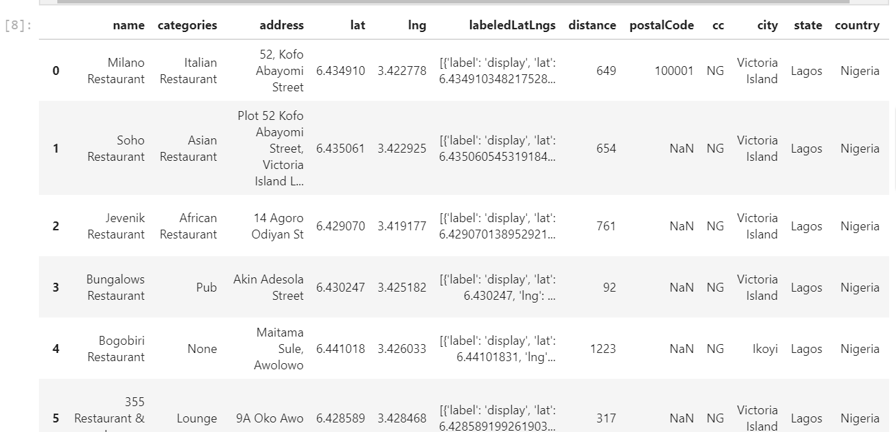

Figure 1 few restaurants in Victoria Island and there details

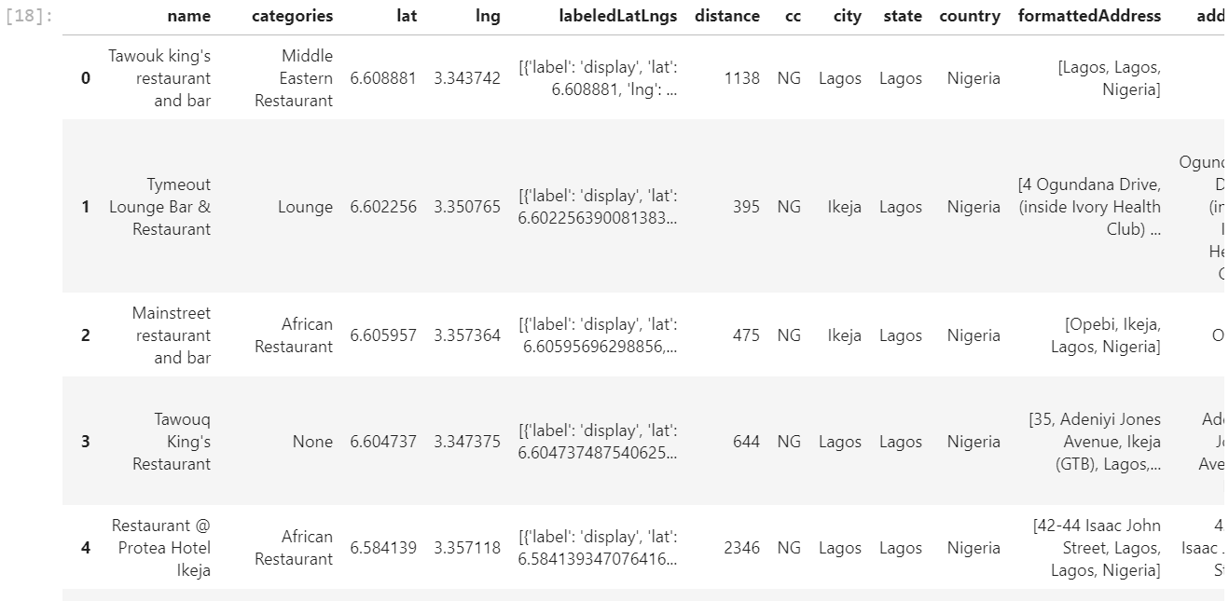

Figure 2 few restaurants in Ikeja and their details

**Result Section**

Victoria Island has a total of 30 restaurants and 16 different categories, it has more restaurants options when compared to Ikeja. We have more restaurants in the African section, and 3 each for Indian, Italian, and Chinese.

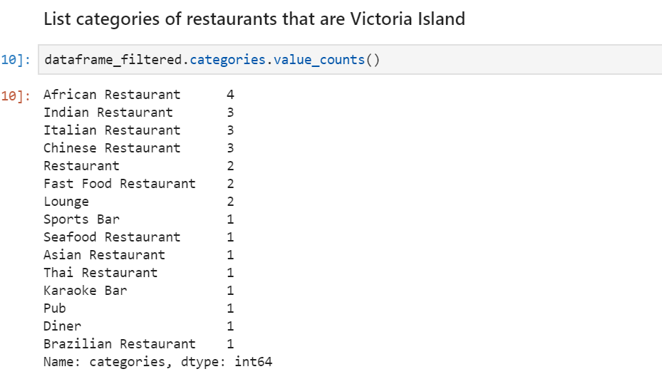

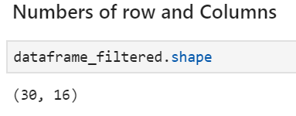

Ikeja has a total of 18 restaurants and 8 different categories, it has more African restaurants options when compared to Victoria Island. Restaurants options are fewer than Victoria Island

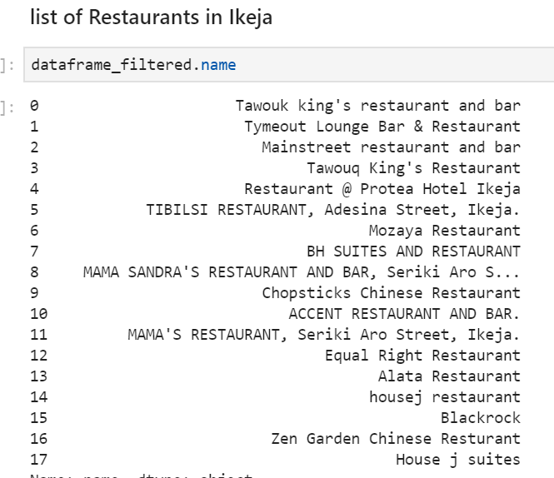

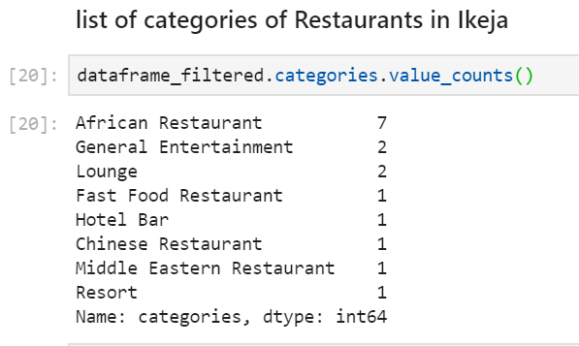

**Discussion**

Victoria Island has more restaurants than Ikeja, almost doubling the figure, and more categories of restaurants. An ardent restaurants lover will prefer Victoria Island to Ikeja because there are more restaurants and different categories to visit. There are more clusters of restaurants, which indicate bee hives activities in Victoria Island. It has more option of foreign restaurants for tourist to visit.

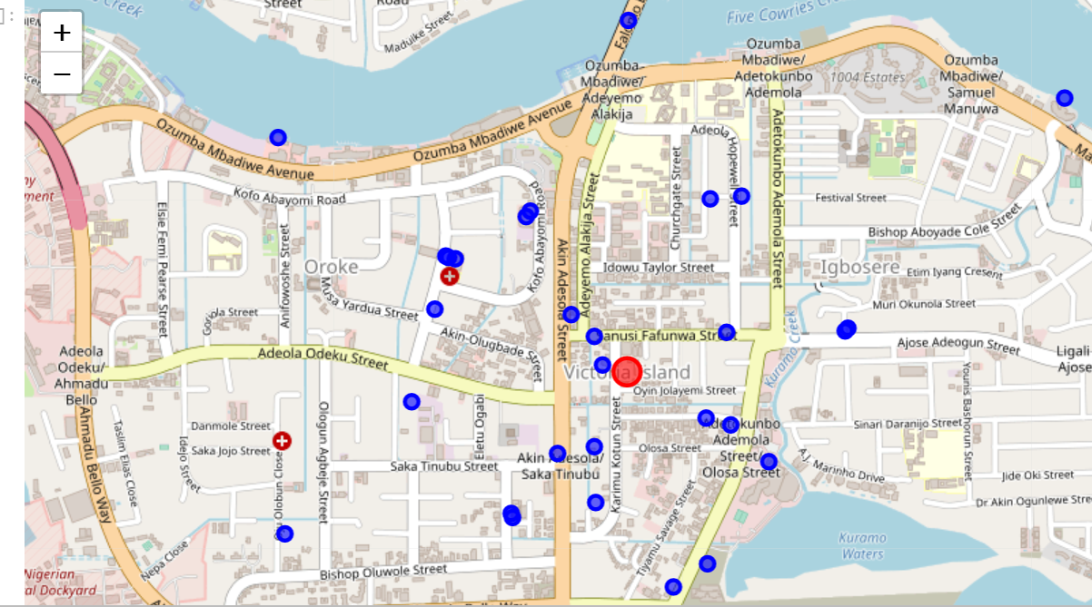

Figure 3 Restaurants in Victoria Island

Ikeja has few clusters of restaurants, the most common restaurants are the African restaurants, hence they are being own by indigenes. Observing the map below, we can see some area that do not have restaurants close to them, hence people in those area have to travel further to get to restaurant.

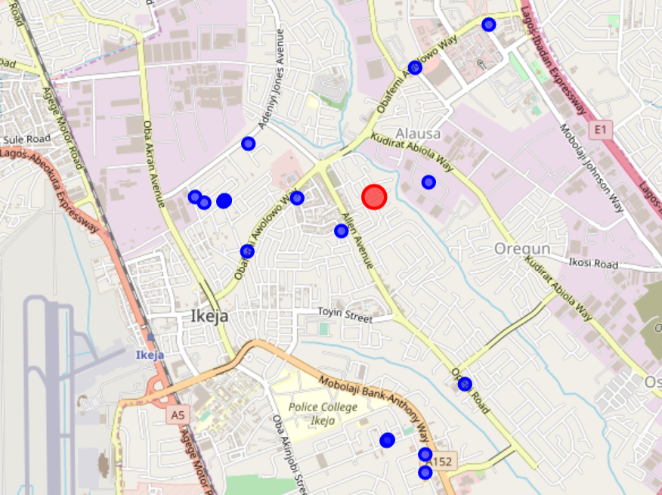

Figure 4 Restaurants in Ikeja

**Conclusion**

In conclusion, if you want to open a restaurant in Victoria Island, you may have decide the type of restaurant you want to open, as Victoria Island is more diverse. Opening an African restaurant may not be as sustainable as other categories. Ikeja is close to the International Airport, hence the need for more foreign restaurant to be able to attract tourist, having a high volume of African restaurant, opening another one close to an existing one might not be sustainable, except you decide to open your restaurant in an area that doesn’t have a restaurant within the vicinity.